

VITYARTHI PORJECT - JAVA

Password Security Manager
Name – Sharayu Sunil
Registration No: 25BAI11286
Subject – Programming in Java

CSE2006
Programming in Java

VIT Bhopal University

1. Introduction

Password Security Manager is a console application coded in Java language and making use of the principles of Object-Oriented Programming in Java. This console application accepts input from the user in the form of user data and website passwords, displays the data received as input, identifies whether the password is strong or weak, determines whether the password is at least of minimum length, and stores the website/password data in a text file in the local computer.

2. Problem Statement

Password management is an issue for users who have more than one account because they are unaware of which passwords are relatively stronger among other passwords. This project will create a simple Java program that can get user and website information, analyze password strength, validate minimum length of password, and store gathered data into a text file.

This is purely an academic local program. It will not have any encryption, secure cloud storage, or other password management system.

3. Objectives

Create a password information management program using Java.

Get user information like name, email ID, website name, and password as inputs.

Analyze the type of password and provide the information related to the password.

Analyze the strength of password as strong, medium, and weak based on the rules created.

Validate the minimum length requirement for the password.

Store website name and password in a local text file.

Learn OOP in Java, exception handling, Scanner input, and file handling.

Create modular source code and manage the code using Git/GitHub.

4. Functional Requirements

The project guidelines require at least three major functional modules, clear input/output, and a logical workflow. The project implements the following modules:
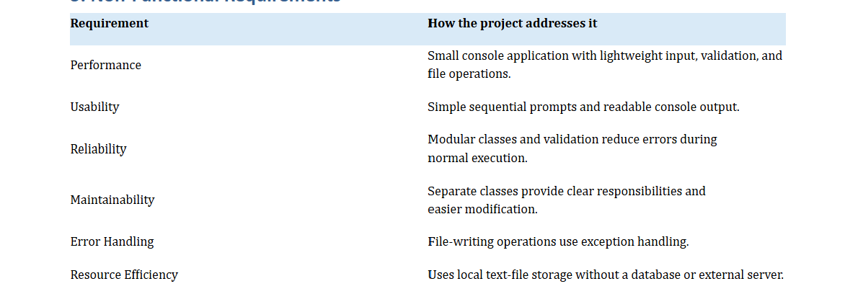

5. Non-Functional Requirements

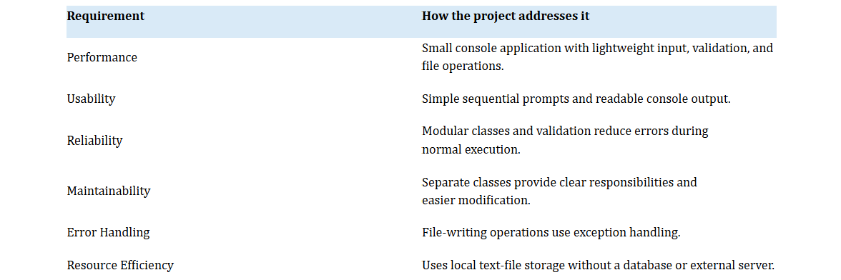

6. System Architecture

The program utilizes a simple console architecture comprising modular components. The MainStart.java file serves as the entry point of the application and controls its operation. The UserInfo.java component processes user information. Classes that process passwords take care of website and password-related information.

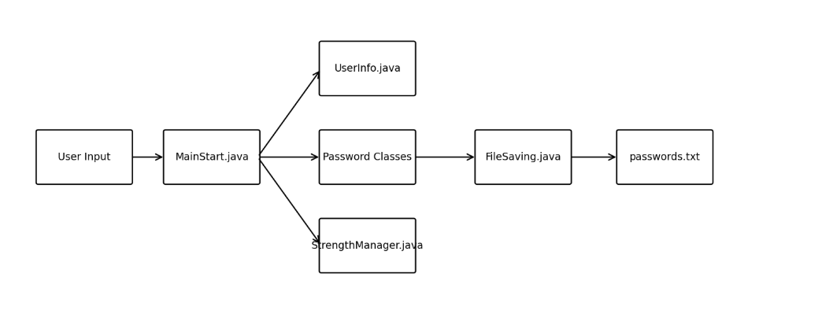
7. Design Diagrams

7.1 Use Case Diagram

The user enters personal and password information, views the results, and uses the application to check and save password information.

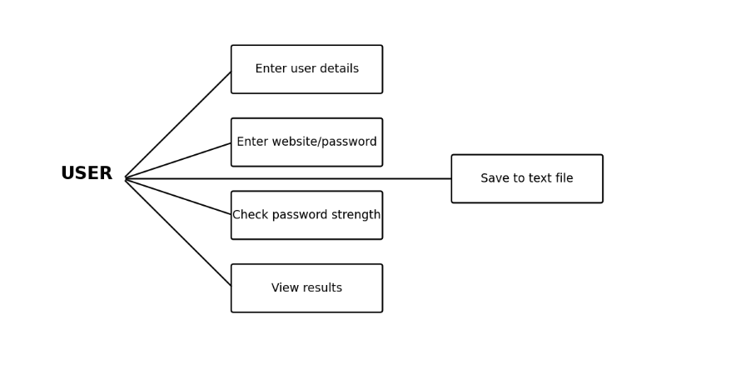

7.2 Workflow Diagram

The workflow begins with user input, proceeds through password processing and validation, and ends with result display and file storage.
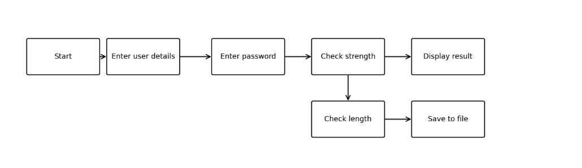

7.3 Sequence Diagram

During execution, the user provides input to MainStart, which coordinates password processing, strength checking, result display, and file saving.

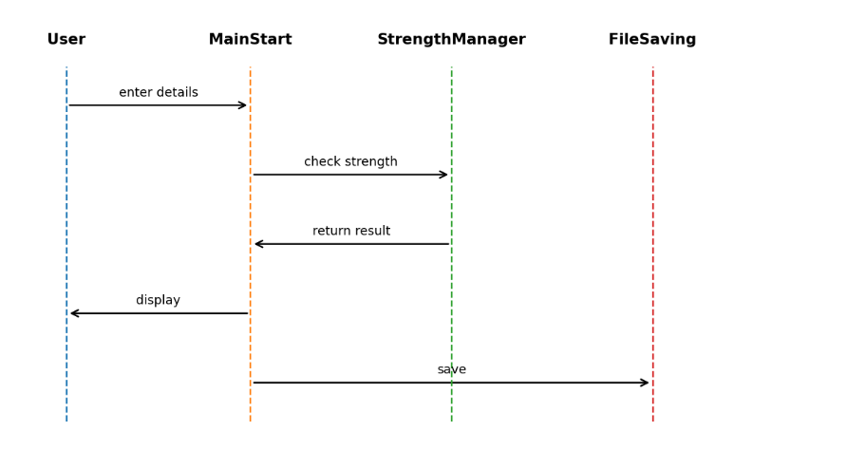

7.4 Class / Component Diagram

The project is divided into meaningful classes including MainStart, UserInfo, Password, StrongPwd, CheckingPwd, InfosPassword, StrengthManager, and FileSaving. MainStart coordinates these components while each class has a focused responsibility.
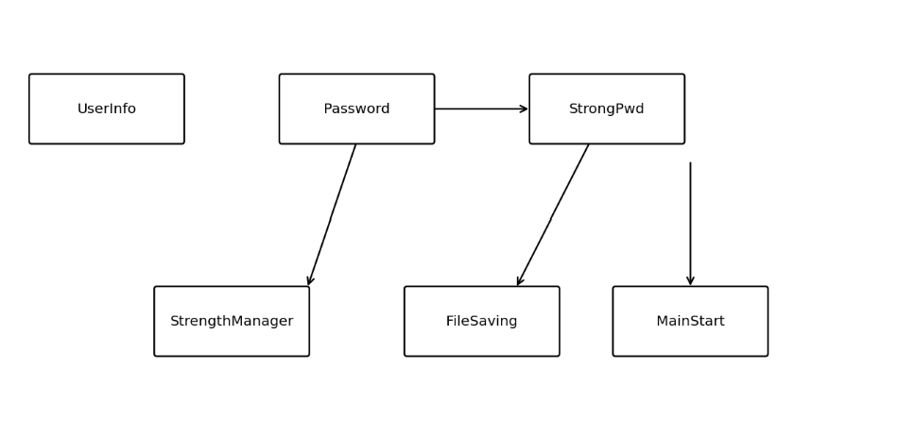

7.5 Storage Design
The application uses a local text file, passwords.txt, rather than a relational database. The logical storage design below shows user/password information flowing into the text-file store.

Decision | Rationale
Console application | Keeps the project focused on Java programming and syllabus concepts.
Multiple classes | Separates responsibilities and demonstrates object-oriented design.
Scanner input | Provides simple interactive console input.
Password-related inheritance | Demonstrates reuse and inheritance in the Java design.
StrengthManager | Keeps validation logic separate from data classes.
Text-file storage | Demonstrates FileWriter and exception handling without database complexity.
Git/GitHub | Provides version control and repository-based submission.
9. Implementation Details

9.1 Input
Scanner is used for accepting name, email ID, website name, and password.
9.2 Password Strength
StrengthManager verifies the password based on the criteria that have been implemented in the source code.
9.3 File
FileSaving is used for writing the website/password info in passwords.txt.
9.4 OOP Concept
Implementation of classes, objects, constructors, inheritance, encapsulation, abstraction/interfaces, method overloading/overriding, and this/super.

10. Screenshots / Results

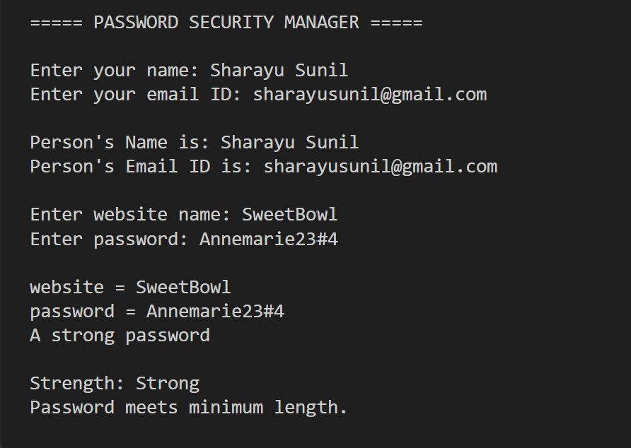

11. Testing Approach
Testing is performed through validation tests of the console application. The project is compiled from its folder and executed through MainStart. Each major input and processing function is checked through console output and the generated passwords.txt file.

12. . Challenges Faced
• Issues related to managing dependencies among various Java classes.
• Issues related to compilation and management of classes and files.
• Issues related to compiling all the source files from the right folder of the project.
• Issues related to performing file writing operations and their exceptions.
• Issues related to organizing README.md and statement.md according to the requirements of the project.
• Issues related to usage of Git commands for adding, committing, and pushing project files.
• Issues related to segregation of source files and .class files in the repository.

13. . Learnings & Key Takeaways
• Knowledge of working together of multiple Java classes in a single application.
• Knowledge of constructors, inheritance, encapsulation, abstraction, and interfaces.
• Knowledge of usage of Scanner for interactive console input.
• Knowledge of validating the password information through methods and conditions.
• Knowledge of FileWriter and try-catch for local file management.
• Knowledge of compiling multiple Java files by javac and running the main class by java.
• Knowledge of organizing the source code and documentation on GitHub.

14. Future Improvements
• Either encrypt the passwords before storing or use hash functions.
• Store the password using a database rather than text files.
• Integrate graphical user interface.
• Authenticate the system to secure the password information stored.
• Include strong password criteria that incorporate length, combination of uppercase and lowercase letters, numeric digits, and special characters.
• Include update and delete operations in storing data.
• Include search facility for websites.
• Include unit testing using Java testing framework.

15. References
16. VITyarthi – Build Your Own Project: General Project Instructions & Submission Guidelines (uploaded project guideline).
17. Materials related to Java courses including Java documentation about classes, inheritance, exception handling, Scanner, and file handling.
18. Git and GitHub materials used for version control operations.

